During 2022 world cup period, I would like to make an example about the football player my favorite—Lionel Messi.

Lionel Andrés Messi born 24 June 1987), also known as Leo Messi, is an Argentine professional footballer who plays as a forward for Ligue 1 club Paris Saint-Germain and captains the Argentina national team. In 24 matches played at the World Cup, Messi has scored 10 goals, which is the best player in America Cup.

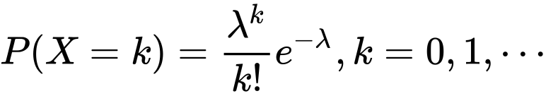

In this case, λ is the average goal-scoring rate, λ=10/25=0.4, a given interval of time is an individual game.

we can use the Poisson distribution to model the probability of him scoring a round number of goals in each match. For example, we can use the Poisson distribution to calculate the probability of him scoring 1 goal, 2 goals, or any other number of goals in a single match. This can be useful for predicting the outcome of a match and for making statistical comparisons between different players or teams.

Overall, the Poisson distribution can be a useful tool for modelling and analysing data related to goal-scoring in soccer, and specifically for analysing the performance of specific football player at the FIFA World Cup.

Reference:

Olympics (Ed.). (2022, December 10). Lionel Messi’s goal-scoring record at FIFA World

Cups: Level with Argentina’s top scorer Gabriel Batistuta. Olympics.

https://olympics.com/en/news/lionel-messi-goals-fifa-world-cup-football

Wikipedia contributors. (2022, December 12). Lionel Messi. In Wikipedia, The Free Encyclopedia. Retrieved 04:22, December 12, 2022, from <https://en.wikipedia.org/w/index.php?title=Lionel_Messi&oldid=1126928972>

Yakir, B. (2001). *Introduction to statistical thinking (with R, without Calculus)*. The Hebrew University of Jerusalem.